SIMATS ENGINEERING
ASSESSMENT TOOL 1
COURSE NAME: COMPUTER NETWORKS
COURSE CODE: CSA07

COURSE OUTCOME COVERED
CO5:
Design network topologies star, mesh, bus, and hybrid using networking devices, transmission media, and cabling standards
(BL2,BL5)
Assessment Tool Weightage: 40%
QUESTIONS: 3 Total Marks: 30
Annexure A
Constraint-Based Problem Solving

Code of Conduct:
I EKALAIVAN L. 192524450 (Name / Reg No) certify that this submission is my original work
and that I have adhered to the guidelines specified for this assessment.
I understand that any violation of academic integrity rules will result in disciplinary action.
Signature of the student:
EKALAIVAN L.
ANSWERS
Question 1: Connectivity Design for a Remote Branch Office
Problem: A new branch in a rural area has no wired high-speed internet, but must run cloud applications, video conferencing, and secure communication with headquarters on a limited budget, with uninterrupted operations.
Constraints Identified
- Bandwidth: Enough capacity for cloud apps and video conferencing without wired broadband
- Reliability: Business operations must not stop even if one link fails
- Cost: Limited budget rules out laying new fiber to a remote site
- Scalability: Solution must grow as the branch adds users or services
Recommended Solution
- Primary Internet Link: VSAT satellite internet — available anywhere without wired infrastructure, and modern VSAT plans give enough throughput for cloud applications and compressed video calls
- Backup Internet Link: 4G/LTE cellular data as a secondary WAN link, used automatically if the satellite link degrades or drops
- Core Device: An SD-WAN router/firewall with dual-WAN support — it monitors both links and fails over to the backup within seconds, with no manual action needed
- LAN Devices: A PoE switch for wired office devices and a WiFi access point for staff laptops/phones
- Security Mechanisms: A site-to-site IPsec VPN tunnel from the branch router to HQ so all traffic to headquarters is encrypted; a firewall with intrusion prevention on the router; and multi-factor authentication for staff logging into cloud applications
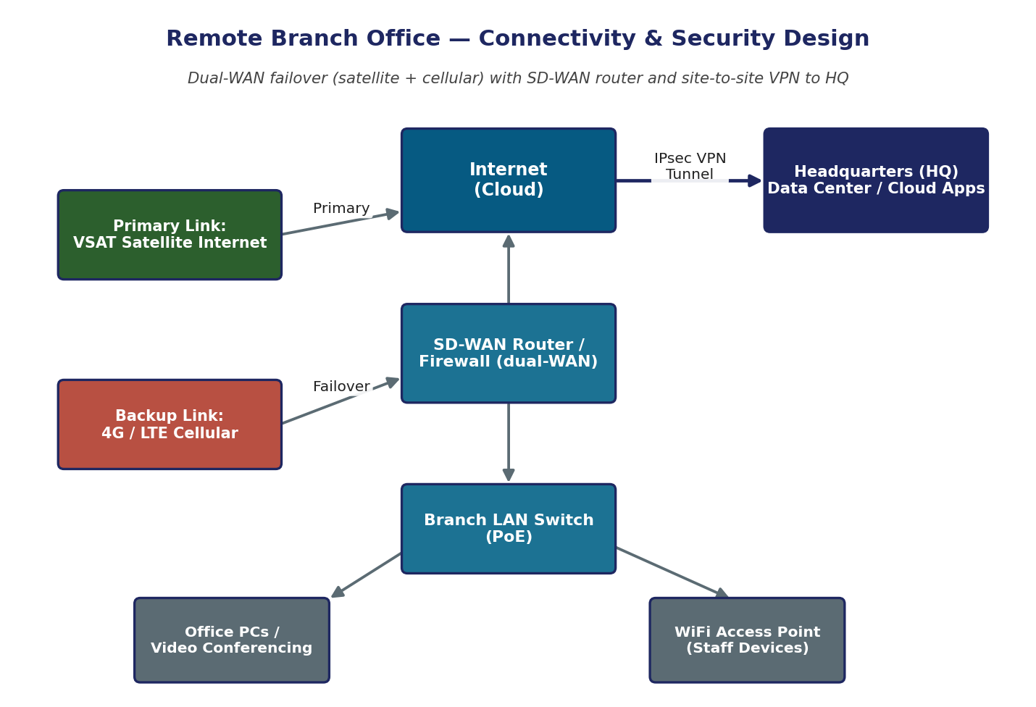
Figure 1: Dual-WAN branch connectivity with SD-WAN failover and site-to-site VPN to HQ
Justification Against Constraints
- Bandwidth: VSAT and LTE plans can be sized to the branch's actual usage, and QoS on the SD-WAN router prioritizes video conferencing traffic over background data, so calls stay smooth even on a shared link
- Reliability: The dual-WAN failover means a single link outage does not stop business operations — the router switches to the backup link automatically
- Cost: Satellite and cellular links avoid the high cost of trenching fiber to a remote site, and a single SD-WAN router replaces what would otherwise need several separate devices
- Future Scalability: Because the applications are cloud-based, the branch does not need new servers as it grows — only the internet plan needs to be upgraded, and the SD-WAN platform can be extended to additional branches using the same design

Question 2: Campus-Wide Wireless Network Design
Problem: A university needs WiFi for 3,000+ students across classrooms, labs, library, and hostels, supporting many simultaneous users with minimal interference, secure access, and only a limited number of access points due to budget.
Requirement Analysis
- High User Density: Thousands of concurrent devices, concentrated in specific zones at specific times (e.g., lecture hours)
- Limited Access Points: Coverage and capacity must be achieved with as few APs as possible
- Interference: Overlapping signals between nearby APs and buildings must be minimized
- Security: Only authorized students/staff should connect, and traffic must be encrypted
Proposed Wireless Network Design
- Access Point Placement: Deploy AP clusters zone-by-zone — one cluster per building (classrooms, laboratories, library, hostels) — placed centrally in each floor/wing based on a site survey, so each AP serves the maximum number of users with the least overlap with its neighbors
- AP Type: Use enterprise-grade dual-band APs that support WiFi 5/6 with MU-MIMO and OFDMA, since a smaller number of high-capacity APs can serve more simultaneous users than many low-end APs, keeping hardware cost down
- Frequency Band Selection: Use the 5 GHz band as the primary band in classrooms, laboratories, and the library, because it offers more non-overlapping channels and higher throughput for dense areas; keep 2.4 GHz active mainly in hostels and as a fallback for older devices, since it travels further through walls
- Interference Control: Assign non-overlapping channels (1, 6, 11 on 2.4 GHz; non-overlapping UNII channels on 5 GHz), tune AP transmit power so cells don't overlap excessively, and let the central WLAN controller auto-adjust channel and power as conditions change
- Authentication Method: WPA2/WPA3-Enterprise with 802.1X, checked against a central RADIUS/AAA server tied to the university's student and staff directory, so each person connects with their own credentials instead of a shared password; a separate captive-portal guest network can be used for visitors
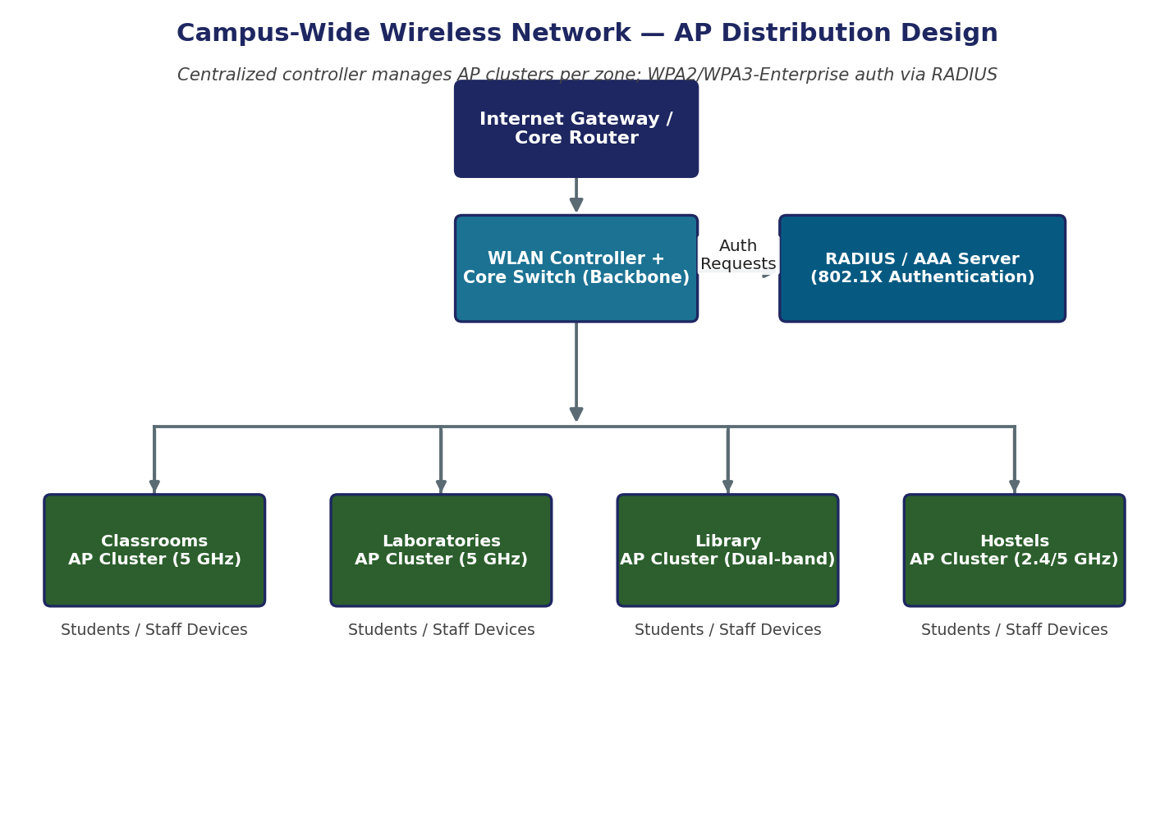
Figure 2: Zone-based AP clusters managed by a central WLAN controller, with RADIUS authentication
How This Balances Coverage, Performance, Security, and Cost
Grouping APs by zone with a centralized controller gives full coverage across classrooms, labs, library, and hostels without needing an AP in every single room. Using higher-capacity, dual-band APs lets each access point serve more students at once, so performance stays high during peak hours even though the total number of APs is limited by budget. Careful channel and power planning keeps interference low despite the high AP density on campus. Centralized RADIUS authentication adds strong, per-user security without any extra hardware at each building, and the phased zone-by-zone rollout lets the university spend its budget on the busiest areas first.

Question 3: Secure Network Architecture for a Financial Institution
Problem: A financial institution must improve cybersecurity for internal access to sensitive customer data and online banking, while complying with strict security policies without hurting performance or raising costs significantly.
Constraints Identified
- Security: Sensitive customer and banking data must be tightly protected from both external and internal threats
- Performance: Security controls must not introduce noticeable delay for employees or online banking customers
- Compliance: The design must support the logging, access control, and data-isolation expected by financial-sector security policies
- Budget: The solution should reuse existing infrastructure where possible rather than requiring a fully separate physical network
Proposed Secure Network Design
- Network Segmentation: Use VLANs on the core switch to separate the network into an Employee VLAN (general staff access), a Customer Data VLAN (sensitive, tightly restricted), and an Admin/Management VLAN (network and server operations), plus a DMZ for the public-facing online banking web servers
- Firewall Deployment: A perimeter firewall with IDS/IPS sits between the internet and the DMZ to inspect all inbound and outbound traffic; a second internal firewall acts as a segmentation gateway between the DMZ/internet edge and the core network, enforcing strict rules on which VLANs may talk to each other
- Authentication: Multi-factor authentication (MFA) integrated with Active Directory for all employee logins, with role-based access control so staff can only reach the systems and data required for their role
- Intrusion Detection: IDS/IPS at the perimeter firewall inspects traffic entering from the internet, with additional internal monitoring focused on the Customer Data VLAN, and all events are sent to a central logging/SIEM system for audit and compliance reporting
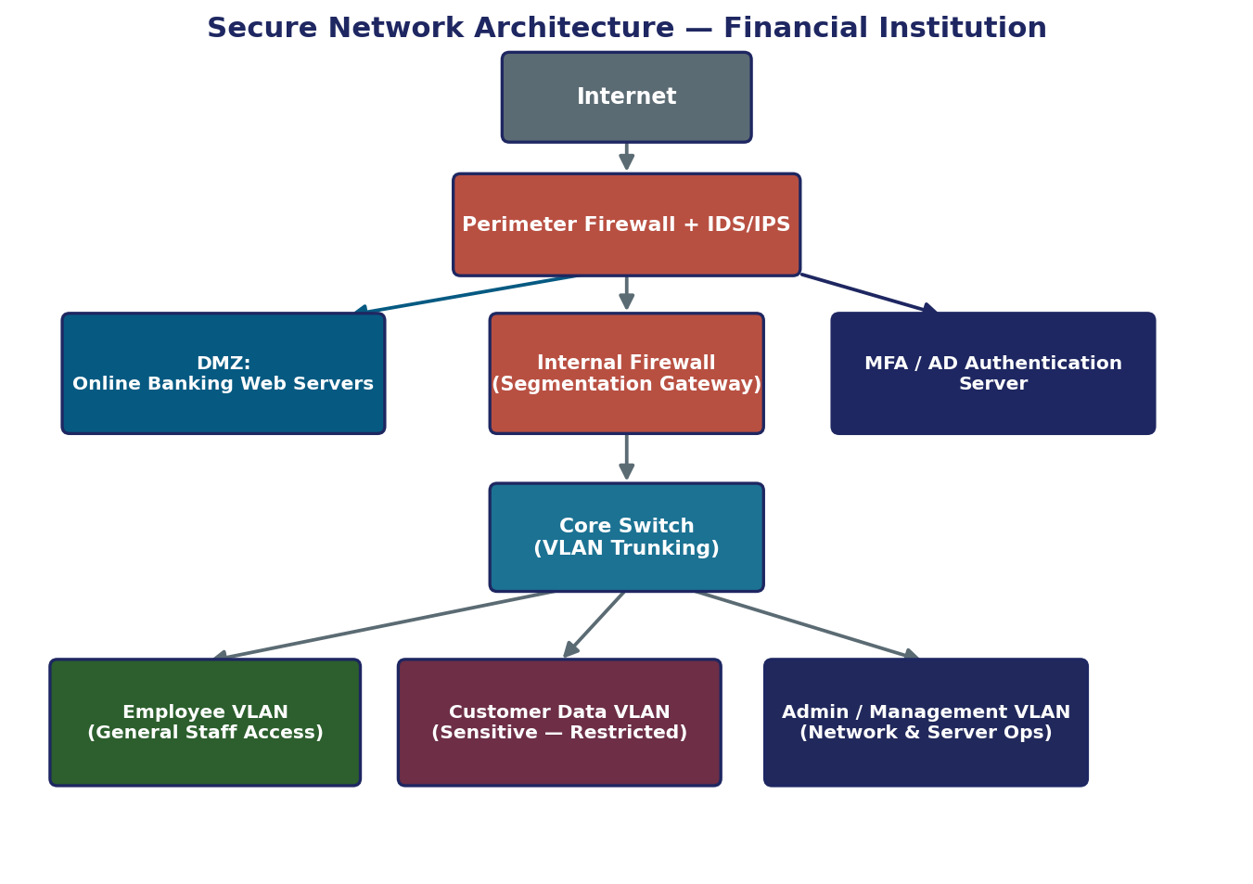
Figure 3: Segmented, defense-in-depth architecture with perimeter/internal firewalls, IDS/IPS, and VLAN isolation
Justification Against Constraints
- Security: Layered defenses — perimeter firewall, internal firewall, IDS/IPS, MFA, and VLAN segmentation — mean a single failure does not expose the whole network, and the most sensitive data sits on its own restricted VLAN
- Performance: VLAN segmentation and firewall rules only inspect traffic that actually crosses a boundary, so normal in-VLAN traffic (e.g., teller workstations to local file servers) is not slowed down by unnecessary inspection
- Compliance: Isolating customer data on its own VLAN, enforcing MFA and role-based access, and logging all security events directly supports the access-control and audit-trail requirements common to financial-sector security policies
- Budget: VLAN trunking on the existing core switch achieves strong logical segmentation without buying separate physical switches for each segment, keeping the design cost-effective while still meeting security goals

